5.2 Polar Coordinates

Cartesian (Rectangular) Coordinates | Polar Coordinates
- Plot points by moving  - horizontally (x-direction) and  - vertically (y-direction)  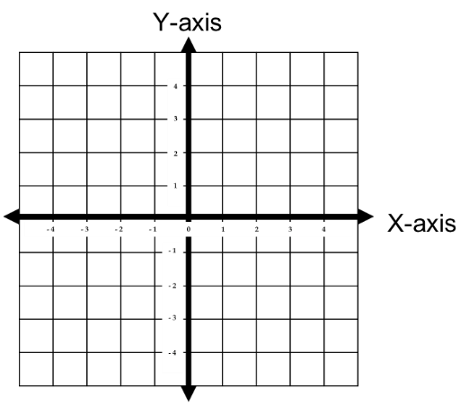  - We have coordinates | - Plot points by  - rotating by a given angle and  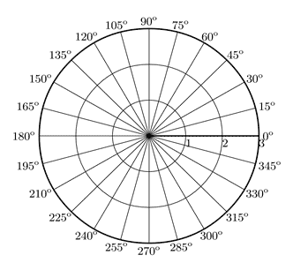  - moving a specified length  Pole  Polar Axis  - We have coordinates


Example 1: Plot the points in the polar coordinate system provided below.
A
B
C & D
- A | - B | - C | - D

Note: There are infinitely many ways to write the coordinates of a point in polar form!!!
To form the same point with different coordinates we simply use an angle that is coterminal with .

Polar –Rectangular Conversions
Converting from polar to rectangular
$$θ$$
$$\left(x,y\right)$$
$$y$$
$$x$$
$$r$$

Converting from rectangular to polar

is any angle in standard position whose terminal side
contains .
( is a reference angle
…adjustments may need to be made)

Example 2: Convert to rectangular coordinates.

$$θ$$
$$\left(6,210°\right)$$
$$y$$

$$x$$
$$6$$

The rectangular coordinates of the point are:

Note that here there is only 1 unique solution.

Example 3: Convert to polar coordinates.
$$θ$$
$$(-3,6)$$
$$6$$
$$-3$$
$$r$$

then we find

Notice that this cannot be since is in quadrant II.

The polar coordinates of the point are approximately:
OR

Note that here there are infinitely many solutions.

Converting Equations

Formulas for converting equations:

Common Techniques:
- Multiplying both sides of the equation by r.
- Squaring both sides of the equation.

Example 4: Write an equivalent rectangular equation for the polar equation: .

We are done.
However, since we can graph this equation and see it resembles a circle we may wish to continue to manipulate the rectangular equation to make it look like an equation for a circle.

We see that this a circle centered at with radius .
Example 5: Use your calculator to sketch a graph of the polar curve given by .
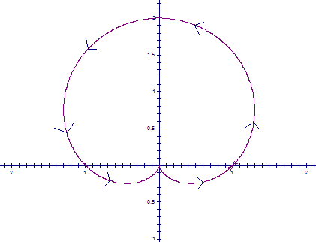
A sketch would be:

Note: This is called a cardioid and it is completely traced as theta varies from 0 to .
Note: We added arrows to indicate how the curve is traced. This will become important later.

Example 6: Use your calculator to sketch a graph of the polar curve given by .
A sketch would be:

Note: This is called a 4 leaf rose. The first half of the first leaf is created as theta varies from 0 to .

Example 7 (you try):
- Convert the point from polar to rectangular (Cartesian) coordinates.
- Represent the point with rectangular coordinates in terms of polar coordinates.
- Use your calculator to graph and sketch the graph your calculator produces.
- Convert the equation from polar to rectangular form.

Solution:
(a) We see the answer is .

(b) We note that and . Since the point is in the fourth quadrant we take (there are many possible choices), and a possible answer is .
(c) A sketch is:

Note: Interestingly this curve is traced as theta varies from 0 to .

(d) We note that .

Note: With some manipulation one can see that the rectangular form equation is the equation of a circle centered at (0.5,0).

Symmetry in Polar Graphs (Optional Material)

Theorem: (Symmetry Tests)
A polar graph is…
- symmetric about the x-axis if replacing by produces an equivalent equation.
- symmetric about the y-axis if replacing by produces an equivalent equation.
- symmetric about the origin if replacing by (or r by –r) produces an equivalent equation.

Example 8: Show that is symmetric about the x-axis, the y-axis, and the origin.

Symmetric about the x-axis:
Original equation:
Replace by : Therefore, is symmetric about the x-axis.

Symmetric about the y-axis:
Original equation:
Replace by :
Therefore, is symmetric about the y-axis.

Symmetric about the origin:
Original equation:
Replace by :
Therefore, is symmetric about the origin.
